Coursework: Aircraft Parametric CAD Model and Performance Assessment
– Assignment Specification and Report Template

Name: Natalie Ko-Ferrigno

In the first assignment of this course, you tried to reconstruct the conceptual design and mission analysis process that the designers of your chosen aircraft undertook. As the outcome, you created the constraint diagram of your reference aircraft and found the wing loading and thrust (power) to weight ratio of your aircraft.

In this assignment, you are asked to create a parametric CAD model of your aircraft, which is used for aircraft performance assessment. This assessment includes aerodynamic analysis for lift and drag estimation, weight estimation, and eventually using aerodynamic, weight, and propulsion specifications for mission analysis to estimate aircraft mission fuel burn. You are also asked to apply geometrical modifications to your reference aircraft to improve its fuel efficiency.

The main deliverable is a report constructed on the template laid out in this document and the VSP file of your aircraft. The assessment is based on the report, and the VSP file will be checked to make sure it is consistent with the report.

For the questions that require an analysis of the open literature, please remember to indicate the sources for every piece of information you supply. Use reputable sources – Wikipedia, web pages with no clear referencing/fact checking/peer review policy should be treated as an absolute last resort, and the numbers should be considered as guesses.

The main tool used for this assignment is the open-source tool OpenVSP, which will be used to create the parametric CAD model and perform aerodynamic analysis. For weight estimation and mission analysis, you need to create your own computer code in any programming language you prefer (e.g., Matlab or Python). Please submit a single file: a pdf version of this document containing your report and the OpenVSP file (.vsp3).

Have fun!

Section 1: Create parametric CAD model in OpenVSP (20 marks)

In the first step, you need to create a parametric CAD model of your aircraft in OpenVSP. In this section, you need to report the following:
- Table(s) of the main geometrical parameters of your aircraft, including airfoil(s), area, aspect ratio, sweep angle, and taper ratio, for the wing, horizontal and vertical tail (or any other lifting surfaces of your aircraft); fuselage length and diameter; engine nacelle length and diameter; propellers diameter, number of blades (if applicable).
- Tables showing the geometrical data of the internal structure of the lifting surfaces, including the number and location of spars, ribs pitch, etc.
- Images showing the OpenVSP model of the aircraft’s external geometry, including different views.
- Image showing the OpenVSP model of the internal structure (for lifting surfaces)

Indicative marks grid:
All the geometrical values are reported and a CAD model of the external geometry is created with minimum details. | 0 - 5
All the geometrical data are reported, and a CAD model of the external geometry is presented with sufficient details | 6 - 10
All the geometrical data are reported, and a CAD model of the external geometry is presented with sufficient details. The internal structure of the lifting surfaces is modeled with minimum details. | 11 – 15
All the geometrical data are reported, and a CAD model of the external geometry is presented with sufficient details. The internal structure of the lifting surfaces is modeled with sufficient details. Additional details of the geometry (external or internal) are presented. | 16 - 20

Page limit: do not exceed the rest of the page plus two others.

In Table 1, the values are converted to metric. For completeness, the original value is also given in brackets.
Parameter | Value | Source
Aircraft length | 8.28 m (27ft 2in) | [1]
Aircraft height | 2.72 m (8ft 11in) | [1]
Propellor diameter | 1.93 m (76in) | [1]
Propellor blades | 2 | [1]
Main wing
Airfoil | NACA 2412 | [2]
Area | 16.17 $m^{2}$ (174 $ft^{2}$) | [1]
Span | 11 m (36ft 1in) | [1]
Aspect ratio | 7.48 | [1], Calculation
Tail wing
Airfoil | NACA 0012 | [3], Assumption
Area | 2 $m^{2}$
Span
Aspect ratio | 3.5
Table 1: geometric parameters for different parts of the aircraft

Additional parameters are presented in the mass estimation section.

The locations of the ribs are given in the 15th revision of the Cessna 172 maintenance manual [4], and reproduced in Table 2. The values in the table are given in inches from the centreline to preserve accuracy.
Rib number | Distance from centreline (in.)
1 | 22.875
2 | 39.00
3 | 57.375
4 | 71.125
5 | 85.875
6 | 100.50
7 | 118.00
8 | 136.00
9 | 154.00
10 | 172.00
11 | 190.00
12 | 208.00
Table 2: location of the ribs
The position of the wing spars was not available, so was estimated. This was done using data from the Illustrated Parts Catalogue [5], as well as the maintenance manual. For the vertical stabiliser, no dimensions were given at all so these were all estimated from the Illustrated Parts Catalogue.
Figure 2: four views of the aircraft
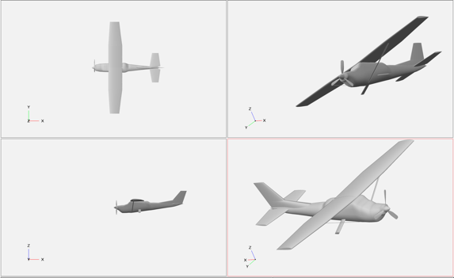
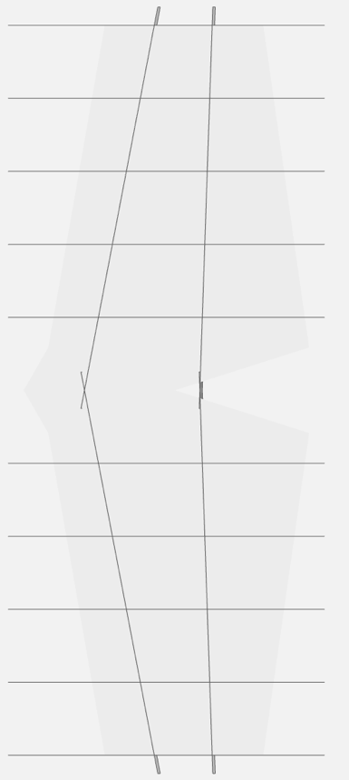

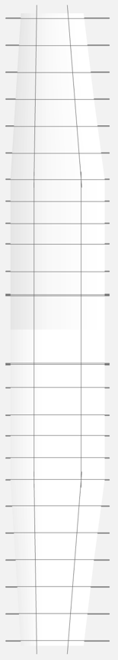

Figure 1: The internal structures of the tail (top) and the main wing (bottom)

Section 2: Aerodynamic analysis (20 marks)
Here, you need to present an aircraft aerodynamic assessment to estimate aircraft lift and drag. You need to use VSPAERO to calculate aircraft lift, parasite, and induced drag. You can choose either the VLM or panel method of the VSPAERO. The report should include the following:
- VSPAERO images of the paneling in VLM or panel method.
- Explanation of which method is used for parasite drag calculation. Also, a clear explanation of which components are included and which components are neglected (if there are any) and a justification of why those components are neglected.
- Aircraft polars include lift vs. angle of attack, drag vs. angle of attack, drag vs. lift, and L/D vs. C_{L}.
- Table of different drag coefficient breakdowns, including the total aircraft induced drag, and the parasite drag for each aircraft component.
- Compare your estimated cruise L/D with actual aircraft cruise L/D, and discuss the error.

Indicative marks grid:
Very little information or incomplete list and plots of lift and drag. | 0 - 5
A sufficient description of the methodology and the required outcomes are presented. The aerodynamic assessment has major flows. | 6 - 14
Clear and complete information. All the requested data and figures are provided. No major flaws in the analysis. | 15 - 20

Page limit: do not exceed the rest of this page plus one other.
Using X-Z symmetry lead to a closed mesh warning, which would hide any other mesh issues in the solver console. For this reason, no symmetry was used.
The only neglected component was the propellor geometry. At 0 and 15 degrees angle of attack, this only made no significant difference.
To allow for high panelling density with no rotationality in the potential flow, the panel method was chosen
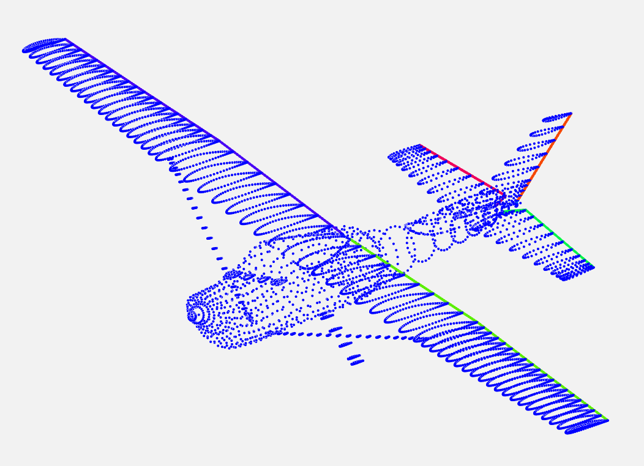
Figure 3: panelling of the model

As shown, the panelling for all surfaces was higher where geometry changed. This is to better capture aerodynamic gradients for greater accuracy at a constant computational time.
For all graphs, the reference dimensions are those of the main wing.

The lift curve slope is shown below. Xfoil indicates that at the Reynolds number used, $1×{10}^{7}$, the flow will stay attached until $α≈{17}^{∘}$. This means that the lift curve slope will should still be linear at the maximum angle of attack used of 15, meaning that this lift curve slope should be accurate. This allowed for a stall model to not be used.
The roughness in the slope also suggests that there are some issues in the convergence, and these may be resolved by increasing the number of wake iterations. This will result in longer computational times, so is not done here.
The average lift curve slope, as calculated through numpy, is 5.68. Lanchester-Prandtl lifting line theory would predict that this should be lower, at 4.93. This error will be a result of all of the other lifting surfaces, such as the tail, landing gear fairings, wing struts the body of the aircraft.
The span efficiency factor was neglected in this calculation, because it would only minorly effect the error.
The plot of drag against lift is a very typical quadratic. $C_{D0}$ is around 0, corresponding with D’Lambert’s Paradox and using the equation for induced drag, the values appear sensible.
The plot of lift against drag has been omitted. Because the lift curve slope is a straight line, there is no additional information to be gained from it, and it is just the drag curve rotated.
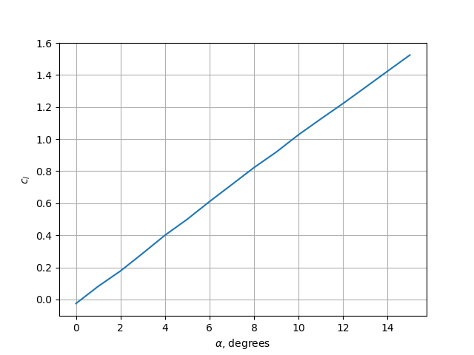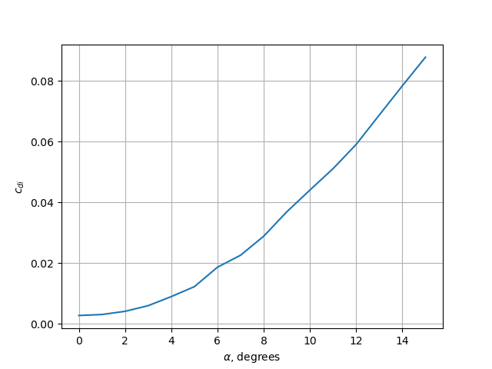
Figure 4: coefficient of lift and drag against alpha
This graph is somewhat inaccurate, as the real maximum lift to drag ratio for the Cessna 172 is around 14, as is given in Raymer.

The total coefficient of parasitic drag is 0.0089. This was added to the induced drag for the lift to drag ratio calculations to accurately represent the forces at cruise.

From the handbook, a cruising speed is listed as 124keas at 8500ft. Maximum takeoff weight is assumed for the whole cruise, so it is likely that the lift coefficient will be lower. converting to metric and finding the relevant coefficient of lift gives the cruise lift coefficient as 0.36.
Component | Percentage {%}
Fuselage | 25.48
Main wing | 45.50
Tail wing | 11.10
Wing strut | 1.16
Vertical stabiliser | 7.18
Propellor | 7.80
Gear | 1.78
Table 3: Percentage of total drag for each item
This would give a glide ratio of around 7.
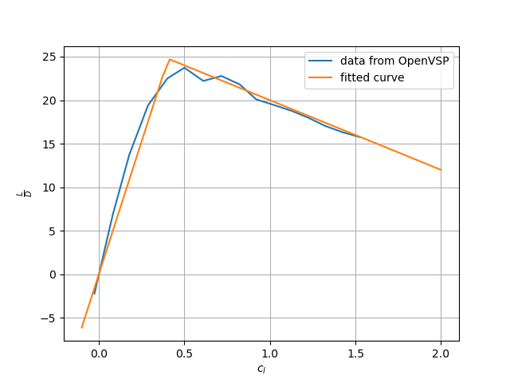
Figure 5: Lift over drag against coefficient of lift with a curve fitted

Section 3: Weight estimation (20 marks)

Here, you need to present aircraft weight estimation using a Class II method of your choice. This section should include the following:
- Description of the methodology (the class II) method you used by mentioning the source, e.g., Raymer, Torenbeek, Roskam, etc. You do not need to write all the equations in the report.
- Explanation of how the different input values are determined. It can be done, for example, using a table with a column showing input parameters for each component weight estimation, a column with the values (and unit), and a column explaining how you determined (or where you found) those values.
- Table of weight breakdown of your aircraft and the total operational empty weight.
- Compare your estimated operational empty weight with the actual aircraft operational empty weight and discuss the error.
The weight estimation usually needs some iteration to converge, as you usually need the aircraft weight as an input for weight estimation. In this section, please only show the final (converged) values of weights. You need to explain the iteration process in the next section.

Indicative marks grid:
Limited description of the methods, and an incomplete list of inputs and outputs. | 0 - 5
Sufficient description of the methods, and complete list of results. Not sufficiently clear explanation how the inputs are determined. Major flows in weight estimation. | 6 - 15
Sufficient description of the methods, and complete list of results, with acceptable explanation. No major flaws in weight estimation. | 16 - 20

Page limit: this section should fit into the rest of this page plus one other.
The Cessna weight estimation method, as given in Roskam, was used.
Where available, numbers directly from the Pilot Operating Handbook or the Cessna website were used, however in some circumstances the OpenVSP model was used to show the values.
This will ideally be reliable, as the model was based off a three-view drawing from the Pilot Operating Handbook, but they lead to some error. These are listed as OpenVSP.

As the Cessna method assumes Imperial units as an input, all numbers were kept in Imperial as far as possible, and then converted out at the end. The units in the Pilot Operating Handbook were primarily Imperial, allowing for minimal additional error from converting units.

The weight of the electric subsystem was also included. This is because the model used, the 172S, has a significant amount of avionics, which are not accounted for elsewhere. As this book was published in 1989, far before flight computers like those in the 172S existed, it seems reasonable to allow for their extra weight

This table gave an estimated weight of 2220.5 lbs. The Cessna website lists the Basic Empty Weight as 1680 lbs, however what this entails is not specified. It is assumed that the difference is due to coolants, lubricants, passengers/crew and their baggage. This number seems reasonable, as there is still weight budget for fuel.
Name (unit) [source] | Value
Wing surface area ($ft^{2}$) [POH] | 174
Aspect ratio (none) [Specification] | 7.32
Maximum load factor ($g$) [14CFR 23.337] | 5.7
Horizontal stabiliser surface area ($ft^{2}$) [OpenVSP] | 36.6
Horizontal stabiliser aspect ratio (none) [OpenVSP] | 3.5
Maximum horizontal stabiliser root thickness ($ft$) [it came to me in a dream] | $$\frac{2}{12}$$
Vertical Stabiliser surface area ($ft^{2}$) [OpenVSP] | 21.5
Vertical stabiliser aspect ratio (none) [OpenVSP] | 1
Vertical stabiliser root thickness ($ft$) [it came to me in a dream] | $$\frac{6}{12}$$
Vertical stabiliser quarter chord sweep angle (degrees) [OpenVSP] | $$10$$
Length of fuselage from firewall ($ft$) [OpenVSP] | 19
Maximum engine power ($hp$) [POH] | 180
Number of people (none) [POH] | 4
Nacelle constant (none) [Cessna method] | 0.24
Landing weight ($lbs$) [POH] | 2550
Ultimate landing load factor ($g$) [Cessna method] | 5.7
Main landing gear shock strut length ($ft$) [POH] | 0
Nose landing gear shock strut length ($ft$) [POH] | $$\frac{5}{12}$$
Propulsion constant for natural aspiration (none) [Cessna method] | 1.1
Fuel weight ($lbs$) [POH] | 330.55
Table 4: parameters used for the Cessna class II weight estimation method
Because there was so much uncertainty in this value, the estimator was run many times, with each value allowed to change with a uniform distribution of 10%. Running this 100,000 times gave the histogram seen below. While there may be error in the measurements, this suggests that most values will still be within 10% of the expected value.

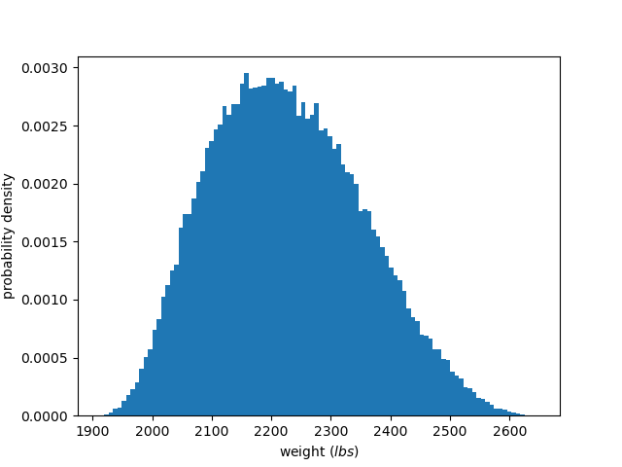
Figure 6: Histogram showing how 10% error on all values may manifest on the final weight

Section 4: Mission analysis (20 marks)

In this section, you need to use the outputs of the aerodynamic and weight analysis together with the propulsion specification of your aircraft to estimate the aircraft mission fuel burn. The section should include the following information:

Equations used for mission fuel burn analysis.

The input data used for the mission fuel burn calculation, including mission profile, propulsion specifications, and weight fractions for different mission segments. Please include the source of these data.

Explain the iteration strategy to converge on aircraft weights (fuel weight, operational empty weight, and maximum take-off weight). Please include the stopping criteria for iteration and the plot of convergence history.

Plot the convergence history, i.e., fuel weight, OEW, and MTOW values vs. iteration numbers.
- Aircraft weight breakdown including fuel weight, payload weight, operational empty weight, and the sum of them as maximum take-off weight.
- Compare your estimated aircraft fuel weight with the actual aircraft fuel weight and discuss the error.

Indicative marks grid:
The methodology is not clearly presented and not all the outputs are provided. | 0 - 5
The methodology for both mission analysis and weight iteration is presented, and inputs and outputs are described. Major flaws in the analysis. | 6 - 15
The methodology is presented and described in detail, and all the inputs and outputs are mentioned and described. | 16-20

Page limit: this section should fit into the rest of this page plus the other.

Variable | Value | Source
Reserve fuel (kg) | 18.3 | POH section 5-8
Operating empty weight (kg) | 1047 | Section 2
Fuel fraction at start of cruise | 0.95 | POH section 5-19
Propellor efficiency | 0.8 | It was revealed to me in a dream
Density (kg/m3) | 0.948 | POH section 5-21, standard atmosphere
Velocity (ms-1) | 64 | POH section 5-21
Actual range of aircraft at 8500 (NM) | 525 | POH section 5-22
Wing area (m^2) | 16.17 | See section 1
Brake specific fuel consumption (NM-1) | 0.0015 | See calculation below
Table 5: Values for mission analysis calculations
To calculate bsfc, the fuel flow rate is at cruse altitude is 10.4 gallons per hours, the density of avgas is taken as 6.01 pounds per gallon, and the percentage of cruise horsepower is 77%, making the total horsepower 138.6. $\frac{\frac{\text{gal}}{\text{hr}}\text{ × }\frac{\text{lbs}}{\text{gal}}}{\text{HP}}$ will give the result in units of feet, and the conversion of feet to nautical miles will give the brake specific horsepower in units of inverse nautical miles.
For all the iterative methods, the stopping criterion was a certain number of iterations. Hardware is fast enough that 1 second can allow for ten thousand iterations, so there is no need for a more complex stopping criterion.
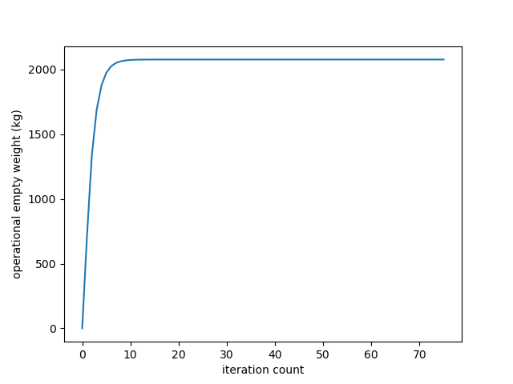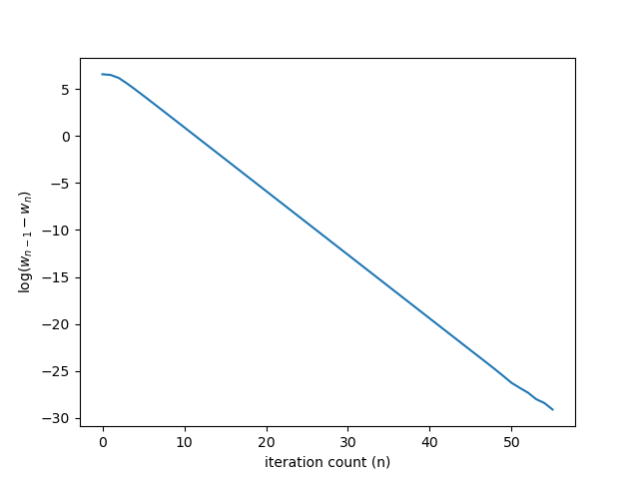
Figure 8: the operational empty weight (left) and the gradient of the operational empty weight (right), both against the iteration count
However if needed, the percentage change in values between iterations could easily be used as they are stored and it is a trivial calculation using Python’s reverse indexing.
Using an iteration limit removes the possibility of the calculation diverging and never reaching a convergence condition and looping forever.
It can be seen that this would happen, as the log of the gradient stops far earlier than the value, as the value stops changing.

The operational empty weight and fuel weight were calculated almost entirely independently, because the fuel weight of the aircraft is given in the handbook, and it seems nonsensical to find this independently.
The calculated operational empty weight was used for calculation of the fuel weight, as this could not be found in the handbook.

A plot of the operational empty weight is given, alongside a plot of the log of the gradient of the operational empty weight, both in Figure 8. The variation in smoothness towards the end is due to the limitations of floating point numbers, and has no meaningful effects.

The lift to drag ratio is above what would be expected, and this is reflected in the fuel burn calculations. 50kg are expected to be needed for the flight, but the fuel tanks are sized for closer to 140kg. A more accurate drag build up would likely mean a better estimation. This could be done though experimental wind tunnel tests, or though higher fidelity CFD. On areas such as the rear windshield, where there is an adverse pressure gradient, potential flow will not model the separation.

Section 5: Design improvement (20 marks)

In this section, you need to suggest modifications in your aircraft geometry to improve the mission fuel burn. For that, you need to modify some aircraft geometry (for example, wing aspect ratio, etc.) and use the code you developed before to re-evaluate the aircraft mission fuel burn. The section should include the following information:

Table of modified geometrical parameters and comparison with their initial values (including the percentages of change)

Explain your rationale behind this modification and discuss the effect of these changes on overall aircraft design.
- Table showing the new aircraft characteristics, including L/D vs. CL for both initial and modified aircraft, main components weight for both initial and modified aircraft, and the final weight values (fuel weight, OEW, and MTOW) for both initial and final aircraft.

Indicative marks grid:
Some modifications are applied, but the results are not showing any improvement. | 0 - 5
Modifications are applied, and improvement is achieved. A minimum level of discussion is presented. Not all of the required information is presented. | 6 - 15
Modifications are applied, and improvement is achieved. A sufficient level of discussion is presented. All of the required information is presented. | 16-20

Page limit: this section should fit into the rest of this page plus the other.
One potential design change is to replace the aluminium spars with carbon fibre, made via a process such as pultrusion. As the spars are almost always in tension, this would likely allow for a significantly smaller part, reducing weight. This would allow it to be manufactured in one continuous part, allowing for small amounts of drag reduction.
This is not a geometry change, so will not be discussed further.

The mission analysis above suggests that the aircraft is flying at around half of the maximum lift to drag ratio. Through flying at 45$ms^{-1}$ instead of 64$ms^{-1}$, the coefficient of lift is increased. Because the gradient is still positive, this will increase the lift to drag ratio. This drops the fuel burn to 77.9kg.

One geometry change that was made was that the horizontal stabiliser’s aspect ratio was increased, while the area was kept the same.
This decreased the weight of the aircraft according to the weight estimation.
Additionally, the higher aspect ratio should increase the lift curve slope of the tailplane, which will improve it for the entire aircraft. A more efficient aircraft will decrease the fuel burn.

Additionally, the main wing’s aspect ratio was decreased from 7.32 to 7. This will have a minor impact on the aerodynamic efficiency, but as aspect ratio is very costly in the Cessna weight estimation method, the weight will decrease dramatically. This was simply done by reducing the span, which also decreased the area from 174 square foot to 161.

These two changes decreased the operational empty weight from 2247lbs to 2154lbs, for a 4% weight saving.

This results in very small amount of fuel saving, with 48.3kg now being used. As was shown above, this is likely wildly inaccurate, so the real weight saving may in fact being higher.

The operational empty weight and fuel weight for the original aircraft are shown above. They are 2220.5 lbs, and 50.1kg respectively, for a combined maximum of 1057.3kg.
The operational empty weight of the modified aircraft is 977.1kg, the fuel weight is 48.3kg, for a combined maximum of 1025.4kg.

This marginal improvement is likely not worthwhile. As the most produced aircraft in the world, the Cessna Aircraft Company likely has efficient tooling and processes for manufacturing these components. To set up carbon fibre manufacturing would likely be more expense than is worthwhile, and changing the wing geometry is also likely to increase production costs.
Additionally, there will be structural constraints with a shorter wing, as the modeshapes will change.

References:

[1] – 172S NAVIII Information Skyhawk SP Manual, 5th ed., Cessna Aircraft Co., Wichita, KS, 2005
[2] – The Incomplete Guide to Airfoil Usage, University of Illinois, 1994 – present. [Online]. Available: https://m-selig.ae.illinois.edu/ads/aircraft.html
[3] – E. Torenbeek, “Preliminary Tailplane Design” in Synthesis of Subsonic Airplane Design, 1st ed. Delft, Netherlands
[4] – Model 172 Maintenance Manual, 15th ed., Cessna Aircraft Co., Wichita, KS, 1996
[5] - MODEL 172 (SERIES 1996 AND ON) ILLUSTRATED PARTS CATALOG – 24th ed., Cessna Aircraft Co., Wichita, KS, 2016

You need to either find this value in the literature or calculate it from available information.

