# Coursework: Conceptual Design and Mission Analysis – Assignment Specification and Report Template

**Name:** Natalie Ko-Ferrigno

Every aircraft design project begins with the design team aiming to understand the competition! What are the key features of competing aircraft, designed for the same mission, and why did their designers make those choices? Large aerospace companies actually have special ‘tiger teams’ dedicated to the task of unravelling the secrets behind other companies’ designs. Here you get to do the same.

This assignment invites you to attempt to reconstruct the conceptual design and mission analysis process that the designers of your chosen aircraft undertook. This is your opportunity to use the open literature and constraint analysis methods to unpick the reasons for the most fundamental design decisions that shaped the aircraft of your choice.

You will not be assessed on the accuracy of your estimates – indeed, in most cases there is no public domain information against which we could do that. Rather, the goal is to come up with a *plausible* conceptual design narrative consisting of your best guess of a design brief (based on a typical mission definition), a set of aerodynamic and propulsion performance estimates and a constraint analysis. You may find useful numbers in the open literature (flight test results, mission descriptions, wind tunnel data, etc.) required for parts of this reconstruction work, but if you cannot, that is not a problem – once again, a plausible, self-consistent guess of the journey that may have taken the design team to the design of the aircraft is the main goal.

The main deliverable is a report constructed on the template laid out in this document; indeed, please use this actual document as a form, which, when filled out, will constitute your design analysis report.

For the questions that require an analysis of the open literature, please remember to indicate the sources for every piece of information you supplied. Use reputable sources – Wikipedia, web pages with no clear referencing/fact checking/peer review policy should be treated as an absolute last resort and the numbers should be considered as guesses.

For the questions that require calculations, we recommend using Python in Jupyter notebook (the Aircraft Design Recipes in Python (ADRpy) library contains everything you need), but you may perform calculations by whatever means you prefer (including by hand, on paper, but you need to transcribe it digitally at the end, of course). **Please submit a single file: a pdf version of this document, containing your report.**

Have fun!

|  |  |
| --- | --- |
| **Section 1: Describe your chosen aircraft (20 marks)** | |
| **This section should contain (exclusively*):**a clear, precise identification of your aircraft: make, model, series, mark, as appropriate  * a photograph and a three-view of your aircraft (do not take up enormous amounts of space with these, but they should be clearly visible); for the three-view make sure you use a credible source, if you’re confident in the accuracy of your own CAD model, you can use a three-view of that too * a clear, precise identification of the propulsion system of the aircraft (make, type, series, mark, etc. of the engine(s) as appropriate), the precise type of engine (e.g., twin-spool turbofan, supercharged V12 piston engine), type of fuel or other energy source (e.g., Jet-A) * propulsive power or thrust (total or per engine, indicate which, also be specific on whether you’re quoting sea level static thrust/max thrust, cruise power/maximum continuous power/take-off power, etc.) * the wing area (projected, total) of the aircraft (in m2) * the maximum take-off weight (MTOW) of the aircraft (in kg) * the MTOW-based wing loading of the aircraft in Pa (show calculation) * concise description of the airframe (e.g., ‘low wing, tricycle undercarriage, T-tail’)   **\*Do not include any other information**. | |
| **Indicative marks grid:** | |
| Minimal or mostly incorrect information, wrong image/three-view, untidy, the reader has to hunt on the page for the required information amongst irrelevant/not required material, wrong units in multiple places. | 0 - 5 |
| Required information mostly present, but imprecise in places (e.g., aircraft only identified as ‘Airbus A340’, or engine type identified, but not the manufacturer, or not clear on exact model/series, thrust rating given as a range for the whole family or the wrong member of the family/wrong numbers, etc.); presentation reasonably clear, but not professional report quality | 6 - 14 |
| Clear, tidy and complete or very nearly complete, presented as one might expect from a professional quality technical report with figure captions and numbers, easily readable, yet not taking up more space than necessary, sources of information clearly referenced. | 15 - 20 |
| Page limit: do not exceed the rest of the page plus one other. | |

|  |  |
| --- | --- |
| Category | Value |
| Aircraft | Cessna 172S |
| Type of engine | Lycoming IO-360-L2A [1] |
| Engine type | Naturally aspirated, aircooled flat 4-cylinder [1] |
| Fuel type | Avgas 100 or avgas 100LL [1] |
| Power (total & per engine) (take off power, max. cont.) | Cruise: 180HP at 2700rpm [2]  Sea-level static thrust: 160HP at 2400rpm |
| Wing area | $16.17m^{2}$ [1] |
| MTOW | $11343N$ [1] |
| Wing loading | 701.5 $Nm^{-2}$ (see below) |
| Description | High wing, tricycle, conventional tail |

Wing loading calculation:

Images from [1]

|  |  |
| --- | --- |
| **Section 2: Conceptual level layout decisions (20 marks)** | |
| **Comment on why you think the designers of the aircraft made the choices they did. Use properly cited, credible reports, articles, papers, etc. (technical reports by reputable organisations, peer reviewed journal articles) where available to support your reasoning. Compare your chosen aircraft to its competitors (aircraft designed for the same mission) and comment on the differences. The section should include:**a clear explanation of why you think the aircraft was equipped with its particular type of **propulsion system**; what alternatives are the design team likely have considered (in terms of the type, number and positioning of engines)?  * a clear explanation of why you think the aircraft has the **airframe layout** it does (think lifting surface configuration, flight control surfaces, high lift system layout); what viable alternatives are the design team likely have considered? What objective metrics would have driven the choices? * a clear explanation of why you think the aircraft was equipped with its particular type of **undercarriage**; what alternatives are the design team likely have considered? Comment on any unusual features, details (e.g., semi-levered gear, electrical brakes) and on the likely reasons for them. | |
| **Indicative marks grid:** | |
| Very little explanation or very vague, generic statements that apply equally to all aircraft of that class/mission and therefore do not actually answer the question (e.g., ‘it has turbofan engines because it has to have a long range’). | 0 - 5 |
| Some depth of thinking demonstrated, beginnings of an analysis of alternatives. Clearly referenced sources included, but of unverifiable credibility (e.g., Wikipedia, web pages with no clear referencing/fact checking/peer review policy). | 6 - 14 |
| Clear, tidy and deep analysis of potential alternatives and cogent, engineering reasoning presented for why the various decisions are likely to have been made. The arguments are precise and, wherever possible, numerical. High quality, scholarly references (journal articles, NASA reports, etc.). | 15 - 20 |
| Page limit: do not exceed the **rest of this page plus one other**. | |

The airframe is clearly not suited for a high-bypass turbofan, and definitely not for a turbojet. Throughout the various iterations of the 172, there has been a general increase in engine power, from 145hp in 1955 to 180HP nowadays. This has allowed for the gradual increase in MTOW from 2200 to 2500lbs.

Due to the 172 being advertised as a trainer aircraft, the complexity of multiple engines is unsuitable for the mission.

It is possible that the design team considered changing the engine for a higher-powered version, as Lycoming’s IO-360 family has higher-powered alternatives, such as the IO-360-K2A. For this engine, dimensions are also identical. However, an alternate rating of the IO-360-L2A was kept, where higher engine speeds lead to higher powers. This is similar to almost every other revision. It is notable that the 172R used the alternate rating of 2400rpm and 160HP on the same engine. When the engine speed is allowed to be increased, a propellor of 1 inch extra diameter must be used. This allows for almost complete interoperability between the aircraft, but an additional 100lbs MTOW.

There are essentially no alternatives to the positioning of the engine, the propellor must avoud the ground when the gas strut landing gear is compressed under breaking, and the engine cowling cannot block the pilot’s view, as an excellent view is a key selling point of the 172.

The high-lift system takes the form of a symmetrical pair of trailing edge flaps. These flaps are of the same area as previous aircraft, and have the same angle at full deployment. Unsurprisingly, this leads to a higher 1g stall speed in the 172S compared to the 172R, with an increase from 51kt to 53kt. This is likely because a change to the geometry of the flaps or range of motion could be a significant enough change that recertification would be necessary. Additionally, the 172 is a level 2 low-speed airplane under 14 CFR 23, and there are no prescribed stall speeds, meaning that any additional cost from decreasing the stall speed is unnecessary.

The flaps use an electric motor connected to a worm gear to actuate the flaps. There is no hydraulic system, and actuating the flaps needs a large amount of power with a small control actuation. For this reason, the cable system used for the other aerodynamic surfaces is not suitable. The addition of a hydraulic system specifically for the flaps would add complexity and reduce engine power available, meaning that the already-limited engine may not be adequate.

A T-tail may have briefly been considered due to the better stability as a result of a lower effect of downwash, but it would also complicate the structure of the tail. Additionally, the control system is driven by a system of cables, meaning that a T-tail would increase length of cable runs, the general complexity of the system, and likely increase the stick force from the pulleys. However, I believe that the main reason is that pre-flight inspections require that the pilot manually check the elevator and trim tabs. A T-tail is therefore unreasonable, as this would require a ladder or very tall pilot. Conventional tails are typical on general aviation craft, likely for this reason.

Additionally, a T-tail could lead to undesirable structural modes when the tail is producing downforce. This would require extra structural mass to account for, and any mass at the tail of the aircraft will lead to a large moment.

The trim tab is asymmetric, only appearing on the starboard side of the aircraft. The elevator on both sides is affected by the trim tab, as the surfaces are mounted to a solid rod. This does mean that there will be some asymmetry in the drag produced when the trim tab is in use. There will naturally be a resulting yaw moment, but this will be small. This does lead to additional maintenance complexity from two different parts for the elevators, but the cabling is dramatically more simple as a result of this.

The strut is an interesting addition. It will cause more drag through interference drag and additional frontal area, but it will reduce the weight necessary for the wing spars. This will allow better takeoff performance.

The landing gear is a tricycle landing gear, as opposed to conventional landing gear. A rear wheel causes a plane to sit at an angle, severely reducing take-off visibility. For student pilots, this will cause additional difficulties and mean that the instructor may miss out on hazards due to the cowling obstructing their view. Additionally, the tail of a conventional aircraft will lift off on a take-off run, causing the handling characteristics to rapidly change. This will cause more difficulties for a student pilot.

Notably, the main landing gear is only supported by angled beams, rather than shock struts. I believe that this is to reduce weight and complexity. The angle that the struts are mounted at is larger than typical, and this will increase their shock absorption capabilities. This will naturally lead to large bending moments and large stresses.

|  |  |
| --- | --- |
| **Section 3: Structures (10 marks)** | |
| **Analyse, briefly, the structural philosophy of the aircraft. This section should contain:**a brief, clear statement of the fundamental structural philosophy of the aircraft (e.g., ‘semi-monocoque construction pressurised aluminium fuselage and carbon fibre composite wings’)  * your best estimate of what the V-n diagram of the aircraft looks like at MTOW. Use ADRpy to construct it or draw your own, but please state all aerodynamic and other assumptions clearly in either case (e.g., where do the various key speeds come from and what the certification basis of your aircraft was/is likely to have been).   Note: if you use ADRpy (or any other code you did not write) to draw the diagram, the expectation is that you spend the time this saves you on a deeper analysis of the aerodynamic assumptions that went into it. | |
| **Indicative marks grid:** | |
| Very cursory description, V-n diagram absent or completely implausible | 0 - 2 |
| Broadly sensible description, V-n diagram has major flaws or assumptions not stated | 3 - 6 |
| Nice description, V-n diagram looks largely plausible, marks at the higher end if the numbers behind the V-n diagram are the results of a more in-depth investigation. | 7 - 10 |
| Page limit: this section should fit into the rest of this page – keep it tidy and concise. | |

The aircraft is an all metal, semi monocoque , unpressurised construction.

The cruising speed is listed as 126 knots true airspeed in Figure 5-8 in the handbook [1], which corresponds to about 109 knots equivalent airspeed. When the 172S was released, 14 CFR 23.335 stated that the minimum design cruise speed should be $V_{c}=33\sqrt{\frac{w}{s}}$, where $\frac{w}{s}$ is the wing loading [3]. For the 172S, this corresponds to a cruising speed of $126KTAS$. Because the Cessna 172 is compliant with regulations, the type certificate will be used instead, which states the cruise speed as $127KCAS$.

Design dive speed must be $1.4V_{c,min}$, which in this case is around $172KEAS$. This is higher than $V_{ne}$ in the type certificate of $163KIAS$. The design dive speed will be left at $172KEAS$, as this is the minimum specified in 14 CFR 23.335. The handbook once again lists this speed as TAS, which I believe is incorrect.

|  |  |
| --- | --- |
| **Section 4: Mission and constraints (50 marks)** | |
| **In Section 1 you identified two key parameters of the aircraft: the propulsive power (or thrust) and the total wing area. Now is the time to work out why the designers of the aircraft will have ended up with those values! This section should contain:**your best estimate of the typical mission profile the aircraft will have been designed for (consisting of representative take-off performance, climb rate, cruising speed, service ceiling, turn rate, stall speed). Note: it may be useful to consider several possible missions, which you believe the aircraft had to be able to satisfy and several points where each constraint would need to be completed (for example several different climb rates at different altitudes)  * constraint analysis plot covering ground roll, climb rate, service ceiling, cruise speed, turn rate and stall; in order to understand the origins of the propulsion performance requirement (power or thrust) and wing area requirement, it may be useful to investigate the sensitivities of positions of the constraints with respect to various design and mission parameters * a point on the constraint diagram indicating the location of your aircraft * include references to the sources of any numbers you were able to find in the literature, indicate which numbers you guessed * an explanation (in no more than 500 words) of **what you learned about your chosen aircraft by doing the constraint analysis,** specifically about which constraint(s) are likely to have driven the choices made by the design team (in terms of wing area and powerplant choice) * if you used the constraint analysis tool in ADRpy, include the input dictionaries and the commands used to generate the diagram(s) (a screenshot or a copy-paste from wherever you wrote the code, Jupyter, etc.). | |
| **Indicative marks grid:** | |
| A cursory attempt at a constraint diagram, mission profile not clear, major errors | 0 - 10 |
| An attempt with some sensible constraints, but no real depth of analysis. Sources of numbers or the way you arrived at them not clear. | 11 - 25 |
| A strong attempt and a complete constraint diagram with broadly sensible numbers. The explanation of why the designers will have chosen the numbers they did, makes sense in general, but it does not clearly reference the process of how you used the constraint analysis to guess the unknown numbers. | 26 - 35 |
| Nice, clear, plausible constraint analysis and the explanation makes your reasoning (that is, how the constraint analysis helped you reconstruct the original design rationale) clear. Formal sensitivity analysis evident, showing how you teased out which elements of the design brief and which aerodynamic parameter affected which constraint and an explanation that makes this clear. The whole analysis together tells a nice, compelling story of how the design of your chosen aeroplane turned out the way it did. | 36 - 50 |
| Page limit: use as much space as you need (within reason), though keep it tidy, concise and the figure(s) at a sensible size. | |

## Using the best glide speed of 67KIAS, as reported in Figure 3-1 [1], and the height and ranges, the best glide angle is $-{6.3}^{∘}$. As taught in SESA1015, the angle of descent when gliding is $\tan{θ}=\frac{D}{L}$ and from this, it can be found that $C_{D}=\frac{2Wθ}{ρV^{2}S}$. From this, it can be found that the minimum coefficient of drag is around 0.097. Knowing that $C_{D}=C_{D0}+C_{di}$, $C_{di}=\frac{C_{L}^{2}}{πeAR}$ and that the aircraft is in equilibrium, the value of $C_{D0}$ can be estimated at around 0.056. This is significantly higher than the value used in the examples of ADRpy, so is likely incorrect. Figure A.10 in [4] shows the drag polar for a NACA2412 airfoil, the profile used in the Cessna 172. This gives a lower bound for $C_{D0}=0.35$, giving some weight to my estimate. It is to be expected that this aircraft will have a larger coefficient of drag than is typical as a result of the fixed landing gear and the strut-braced wing

From the diagram shown, it is clear that the cruise constraint is far above the other constraints, so my be incorrect. This may be due to a high coefficient of drag.

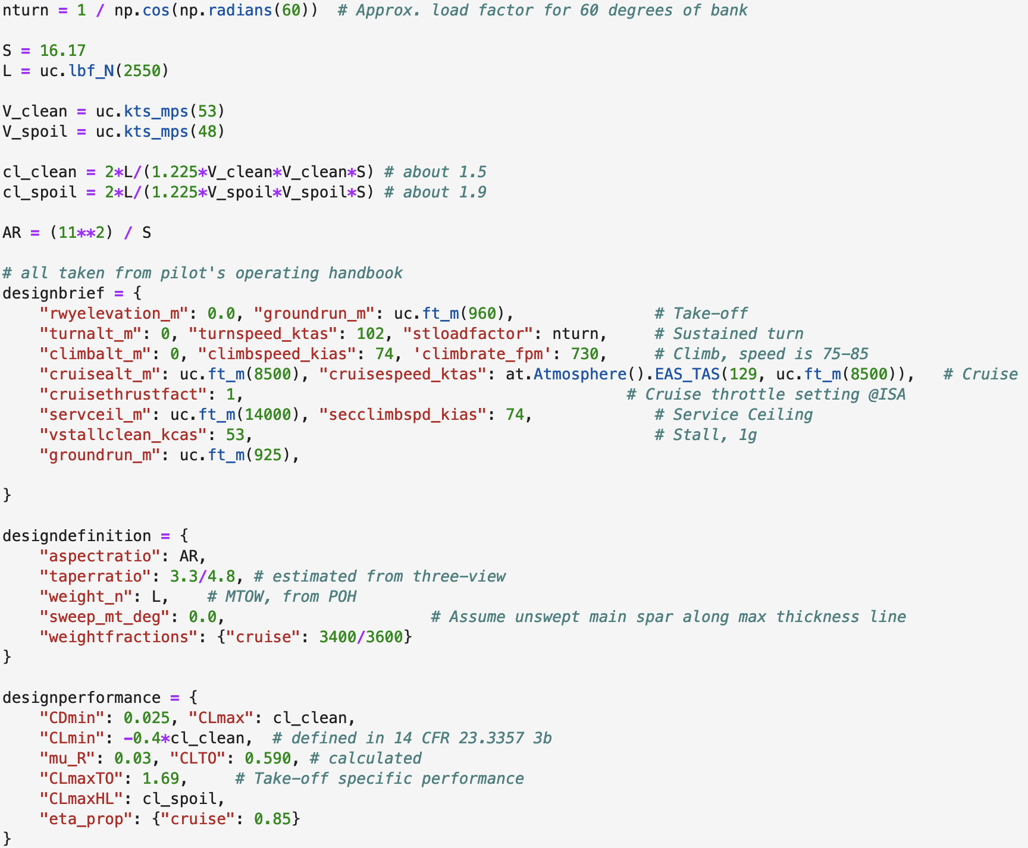

As shown in the screenshot above, a lower $C_{Dmin}$ of 0.025 was used to satisfy the cruise constraint. The fact that the engine was rated for a higher speed means that 160hp is not enough to satisfy this constraint, or else there is no reason for the alternate rating. This still shows the cruise constraint as being far higher than the other contstraints.

The graphs below show how varying the minimum coefficient of drag can affect the power required for the cruise constraint. The graph on the right shows $C_{Dmin}=0.055$, and the graph on the left shows $C_{Dmin}=0.025$. This suggests that assuming the higher $C_{Dmin}$, a cruise constraint of $126KTAS$ makes sense. It is worth noting that the value for best glide speed was taken from the POH, so may also have issues with true instead of equivalent airspeed. Additionally, the graphs were made at a cruise thrust factor of 1, whereas the handbook says the cruise thrust factor should be 0.75. This suggests that some calculation is still incorrect.

# Bibliography

|  |  |
| --- | --- |
| [1] | Cessna Aircraft Company, 172SPHAUS-05, Wichita, Kansas, 2016. |
| [2] | European Union Aviation Safety Agency, “EASA.IM.E.032,” EASA, 2022. |
| [3] | Department of Transportation, “TYPE CERTIFICATE DATA SHEET NO. 3A12,” 2015. |