# Coursework: Computational Fluid Dynamics – Assignment Specification and Report Template

**Name:** Natalie Ko-Ferrigno

In this assignment, you will get hands-on experience with a digital design process, including a digital twin at the centre connected to different numerical analysis modules. Moreover, you will learn how to export geometries, create a mesh, and perform numerical analysis from a digital twin. You will use OpenVSP as a digital design environment, VSPAERO for low-fidelity CFD analysis, and ANSYS Fluent for high-fidelity CFD analysis.

A digital twin (OpenVSP model) of the Falcon 50 business jet aircraft, Fig 1, is provided via Blackboard. In this assignment, you need to use this digital model in the OpenVSP environment and learn how to export it to ANSYS for meshing and high-fidelity CFD simulation. You also learn how to use two low-fidelity CFD models, i.e. Vortex Lattice Method (VLM) and Panel Method (PM), which are available in the aerodynamic analysis module of OpenVSP, named VSPAERO.

Fig 1. Falcon 50 aircraft; a bit discouraging figure, but it is what happens if you do the coursework incorrectly!

The flight conditions of the aircraft required for CFD analysis are given in the table below:

|  |  |  |
| --- | --- | --- |
| **Variable** | **Value** | **Unit** |
| Cruise altitude | 36,000 | ft |
| True air speed | 236.15 | m/s |
| Mach number | 0.8 | - |
| Density | 0.3652 | kg/m3 |
| Temperature | 216.827 | K |
| Total temperature | 244.58 | K |
| Operating pressure (for CFD set-up) | 0 | Pa |
| Supersonic/initial gauge pressure (static) | 22729.3 | Pa |
| Gauge total pressure | 34647.2 | Pa |
| Cruise Reynolds number | 45E6 | - |

Since the aircraft burns fuel during the flight, the weight of the aircraft reduces continuously. Therefore, the value of the required CL for a cruise flight changes during the mission. Each student receives a different design point for his/her analysis. The design point is determined based on the required value of CL, which is:

$$C_{L}=\frac{W_{TO}-W_{Fi}}{0.5ρV^{2}S_{w}}$$

Where $W_{TO}$ is the aircraft take-off weight, $W_{Fi}$ is the aircraft fuel weight at the ith point of the mission (currently remaining fuel weight), $ρ$ is the air density, V is the flight speed, and SW is the wing reference area. The basic design variables for the Falcon 50 are given in the table below.

|  |  |  |
| --- | --- | --- |
| **Variable** | **Value** | **Unit** |
| Wing reference area | 47.566 | m2 |
| Take-off mass | 17,500 | kg |
| Total mission fuel mass | 6,000 | kg |

All the values are the same for all the students, except the value of $W_{Fi}$ as each student gets a different design point. Your design point is determined based on your student number. Please start from right to left and identify the first digit between 1 to 5 in your student number. For example, if the student number of the first student is 30104567, your digit is 5 (30104567). Then pick up your $W_{Fi}$ form the table below.

|  |  |
| --- | --- |
| **Digit** | **Currently remaining fuel mass** |
| 1 | 5000 kg |
| 2 | 4000 kg |
| 3 | 3000 kg |
| 4 | 2000 kg |
| 5 | 1000 kg |

The main deliverable is a report constructed on the template laid out in this document. The assessment is based on the report, so please make sure you provide all the requested information in the report. You will not get the full mark if a task is correctly performed but not correctly reported!

**Please submit a single file: a pdf version of this document containing your report to eAssignment before the deadline. You must use a font size of 11 or larger.**

**Deadline November 20th 2023 at 17:00.**

Have fun!

|  |  |
| --- | --- |
| **Section 1: Low-fidelity CFD analysis (30 marks)** | |
| **In the first step, you need to perform low-fidelity aerodynamic analysis of the Falcon 50 using VLM and PM in OpenVSP using the VSPAERO toolbox. You need to use the digital model of Falcon 50 provided to you, and perform the analysis only for the aircraft wing (not the full aircraft configuration, i.e. excluding all the other components than the wings). You need to run VLM and PM for a range of angle of attack (AOA) from -5 to 10 degrees, with steps of 1 degree. In this section, you need to report the followings:**  * Add two figures showing the panelling in VLM and PM. Discuss and justify your choice of panel density and distribution. * Plot of CL vs AOA for both VLM and PM in the same plot for comparison. * Plot of CD vs CL for both VLM and PM in the same plot for comparison – do not include parasite drag in your CD. * Plot of L/D vs CL for both VLM and PM in the same plot for comparison. * Determine your design point and report the values of AOA, CL, CD and L/D at that point in a table (you might need to interpolate your curves to determine AOA and CD for the design CL). * Run two new simulations, one with VLM and one with panel for the design point and report the new values of AOA, CL, CD and L/D in a table. * Two figure showing Mach contours on the wing (both upper and lower surfaces) in VLM and PM for the design point. | |
| **Indicative marks grid:** | |
| Very little information or incomplete list and plots and figures. | 0 - 5 |
| A sufficient description of the methodology and the required outcomes are presented. The aerodynamic assessment has major flaws. | 6 - 14 |
| Clear and complete information. No major flaws in the analysis, but not all the required information is provided. | 15 - 25 |
| Clear and complete information. All the requested data and figures are provided. No flaws in the analysis. | 26 - 30 |
| Page limit: do not exceed the rest of the page plus two other pages. | |

To see how changing the number of streamwise elements affected the lift-curve slope for vortex lattice methods, a small convergence study was run. To do this, the lift curve slope was found at various numbers of numbers of streamwise elements. The first number chosen was 20, and then this was increased in increments of 10.

This was done for the full range of angles of attack, from -5 to 10. The Reynolds number was set at 4.5x10^7. The Mach number was 0.8, as is the design condition.

As shown in the figure, increasing the number of elemnts lead to a higher lift-curve slope. However, increasing the number of elements any further would result in a crash, so 40 was the number of streamwise elements used. This resulted in a lift curve slope of 4.65.

When coming back to this section, there was a new version of OpenVSP. It appears to have significantly better stability, so up to 65 streamwise elements were tried. As expected, the lift curve slope remained at 4.65.

50 streamwise elements were decided on as the final number of panels for the minor speed improvement.

Increasing the number of elements should increase the accuracy of the results, because more detail on the wing can be resolved. It comes at the cost of logner computational times

Once a number of spanwise elements was found, leading edge clustering was used. It should be changed, because decreasing the clustering increases the number of panels at the front of the airfoil. The front of the airfoil is where the largest aerodynamic gradients are, and they need to be adequately resolved for good accuracy.

The leading edge clustering started off at 1, and decreased in steps of 0.1.

Figure 1:effect of the leading edge clustering on lift curve slope

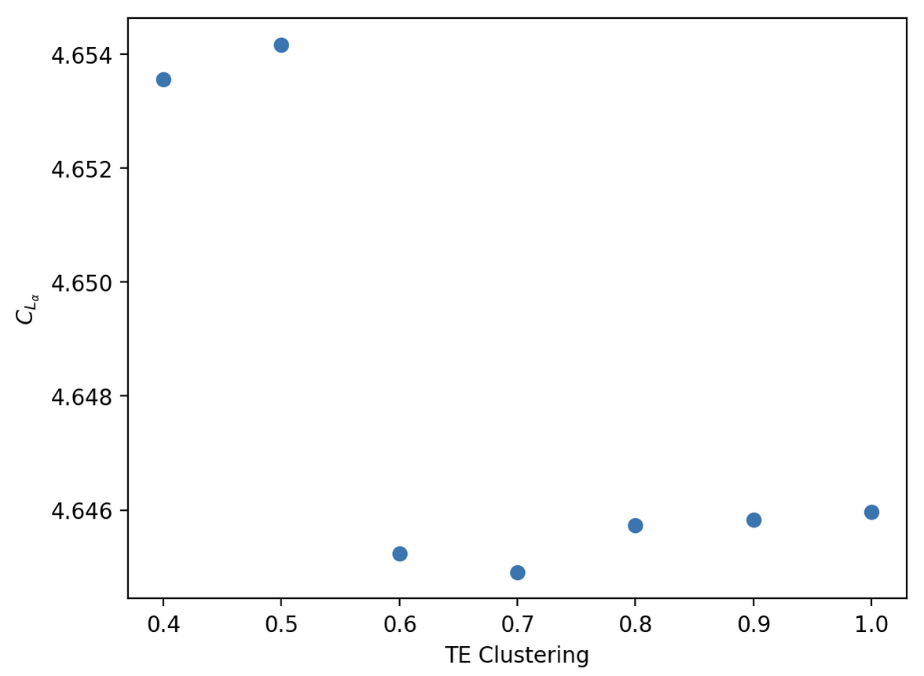

Figure 2: effect of trailing edge clustering on $CL\backslash alpha$

As is obvious from this graph, leading edge clustering has a minimal, but measurable, effect on the lift curve slope. In actual values, this was the variation between 4.654 and 4.645. When rounding the lift curve slope to 3 significant figures, this is no change.

The values of CLA seem to be more stable at lower values of LE clustering, so 0.6 was chosen to proceed with testing trailing edge clustering.

Testing the effects of trailing edge clustering took the same methods as testing leading edge clustering. The same rationale applied here as to the leading edge clustering

This seems more disordered. Luckily, the only value that would change the 3 decimal place lift curve slope is 0.7. It has a value of 4.6449, so is only marginally different to the previous value of 4.65 for the lift curve slope.

To keep everything simple, the chosen value of TE clustering will be 0.6

|  |  |
| --- | --- |
| Streamwise panels | 50 |
| LE Clustering | 0.6 |
| TE Clustering | 0.6 |
| VLM lift curve slope | 4.65 |

For panel methods, the same range of tests will be run.

While testing the convergence for panel methods, decreasing the number of CPU cores increased stability. This obviously came at the cost of increased computational time, but did give the desired results.

Clearly, the number of elements decreased the coefficient of lift and only starts to converge around 100 streamwise elements. Obviously, this takes a long time. For this reason, 90 streamwise elements will be used for trailing and leading edge clustering. This lead to a roughly halved computational time compared to 110 elements.

Almost all of these points give an average of 4.93. Because the lower values of LE clustering are likely more accurate, these will be trusted more. LE clustering will be set at 0.8.

It can be seen that the trailing edge lift slope curve does not converge. The reason that TE.Cl=0.3 is shown instead of 0.2, is that at 0.2, the lift curve slope becomes 0.84.

$\frac{dC_{L}}{dα}=\frac{a_{0}}{1+\frac{a_{0}}{πAR}}$ (1)

Equation 1 gives the lift curve slope for a theoretical wing with aspect ratio $AR$. This will give an upper limit for what a symmetrical airfoil should give. OpenVSP gives an aspect ratio of 7.48, and putting this in Equation 1 gives a maximum lift curve slope of 4.96.

The lift slope curve of the wing will be less than this, because the wing does not have an elliptical lift distribution.

This lead to an angle of attack of 3° at the design point given.

|  |  |
| --- | --- |
| **Section 2: Mesh generation (30 marks)** | |
| **Here, you need to export the wing geometry from OpenVSP to ANSYS. Please use the .igs format for geometry exporting. In this section, you need to create unstructured meshes for Euler (inviscid) 3D wing analysis. Only use half wing with symmetry condition to save computational cost. To prove your analysis is mesh independent, you need to create (at least) three meshes with different cell numbers, one coarse, one intermediate and one fine mesh (the mesh density, including distribution of the nodes, is your choice, and you will be assessed based on whether you selected a reasonable mesh density or not – hint: the mesh density should be chosen by a compromise between accuracy and computational efficiency). Please include the following in your report:**   * A figure showing your domain, i.e. the boundaries of the box and the wing inside that, including dimensions. Discuss and justify your domain sizing. * Mention the boundary condition you used for each surface of the domain. * A table including the number of nodes on the wing surface and the number of nodes and cells on the entire domain for each different mesh. * Figures showing the wing surface mesh for both upper and lower surfaces for each of your three meshes. * Figures showing the mesh on the symmetry plane for each of the three meshes. * Run mesh check and quality evaluation in Fluent and report the results. | |
| **Indicative marks grid:** | |
| Very little information or incomplete list and plots and figures. | 0 - 5 |
| A sufficient description of the methodology and the required outcomes are presented. The mesh generation has major flaws. | 6 - 14 |
| Clear and complete information. No major flaws in the mesh generation, but not all the required information are provided. | 15 - 25 |
| Clear and complete information. All the requested data and figures are provided. No flaws in the analysis. | 26 - 30 |
| Page limit: do not exceed the **rest of this page plus two other pages**. | |

Your answer goes here. Delete this paragraph and start your Section 2 here…

|  |  |
| --- | --- |
| **Section 3: High-fidelity CFD analysis (40 marks)** | |
| **You need to run steady, inviscid, compressible 3D CFD simulations (Euler) for your wing in this section using ANSYS Fluent. You need to run simulations for your design point (cruise condition and your design AOA) for the three different meshes you created in section 2. Please include the following information in your report.**  * Tables showing the choice of solver, solution method and discretisation. * Plots of convergence history of residuals for each simulation. * Plots of CL and CD convergence for each simulation. * Mesh independency plot: plot CL and CD vs. mesh density (cell numbers) for all the meshes. Then, mention your selected mesh among the three as the most suitable mesh and discuss the rationale behind your choice. Discuss and justify that your solution is mesh-independent. * Figures showing the contours of Mach number on both upper and lower wing surfaces for the selected mesh. * Figures showing contours of pressure on three different spanwise positions of the wing: root, 40% of semi-span and 80% of semi-span. * A table comparing the values of CL and CD at design AOA for three different simulations: VLM, PM and Euler CFD and discuss the differences. | |
| **Indicative marks grid:** | |
| Very little information or incomplete list and plots and figures. | 0 - 5 |
| A sufficient description of the methodology and the required outcomes are presented. The CFD analysis has major flaws. | 6 - 20 |
| Clear and complete information. No major flaws in the analysis, but not all the required information is provided. | 21 - 35 |
| Clear and complete information. All the requested data and figures are provided. No flaws in the analysis. | 36 - 40 |
| Page limit: this section should fit into the rest of this page plus three other pages. | |

Your answer goes here. Delete this paragraph and start your Section 3 here…