1)
a)
Kp = 100
Omega = 5 | Omega = 10 | Omega = 15
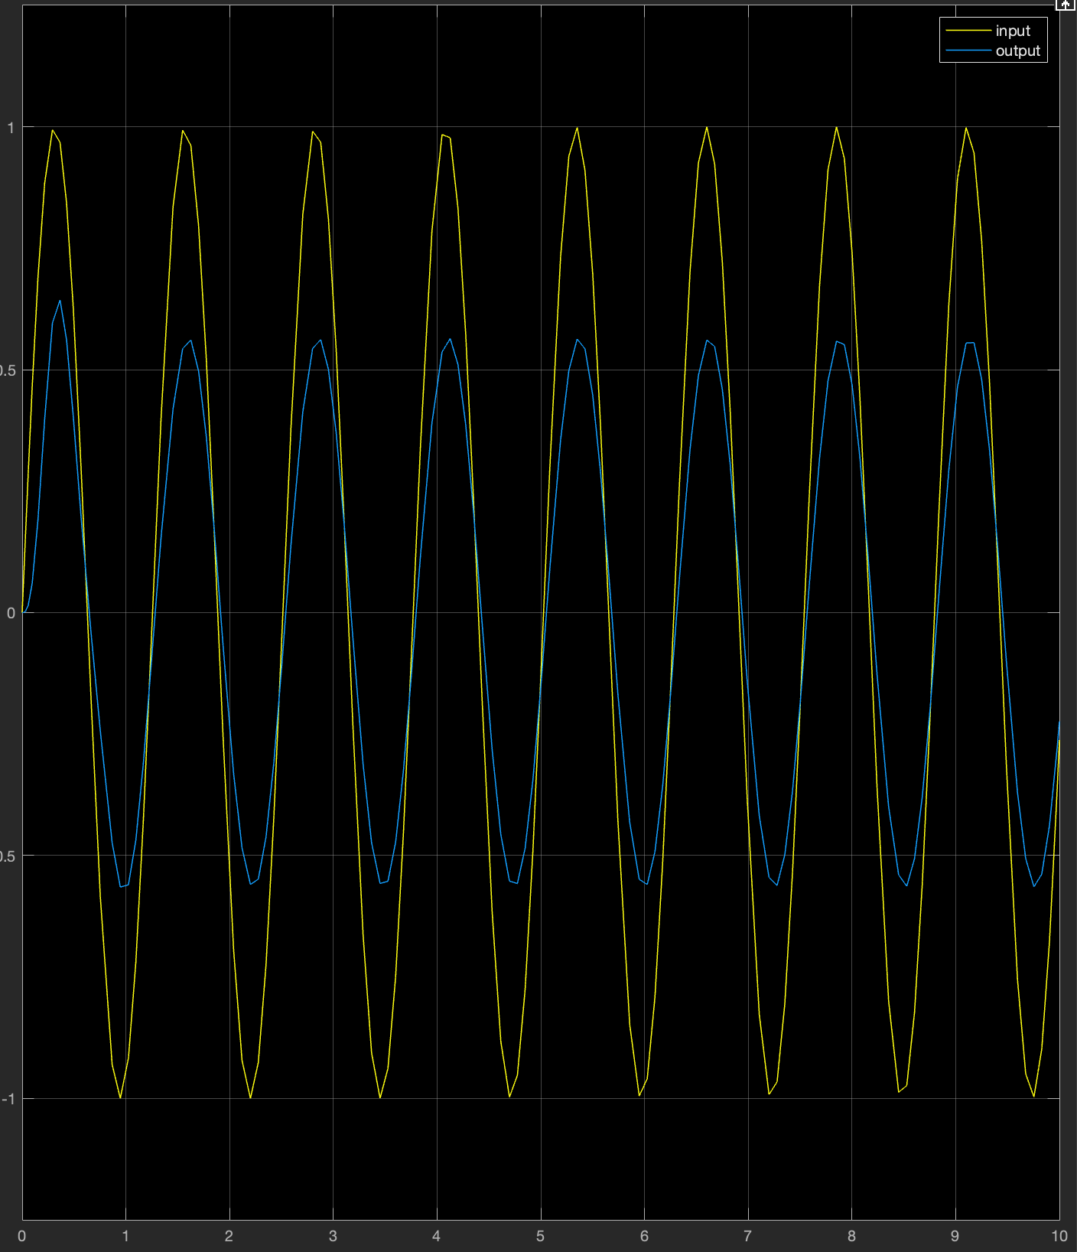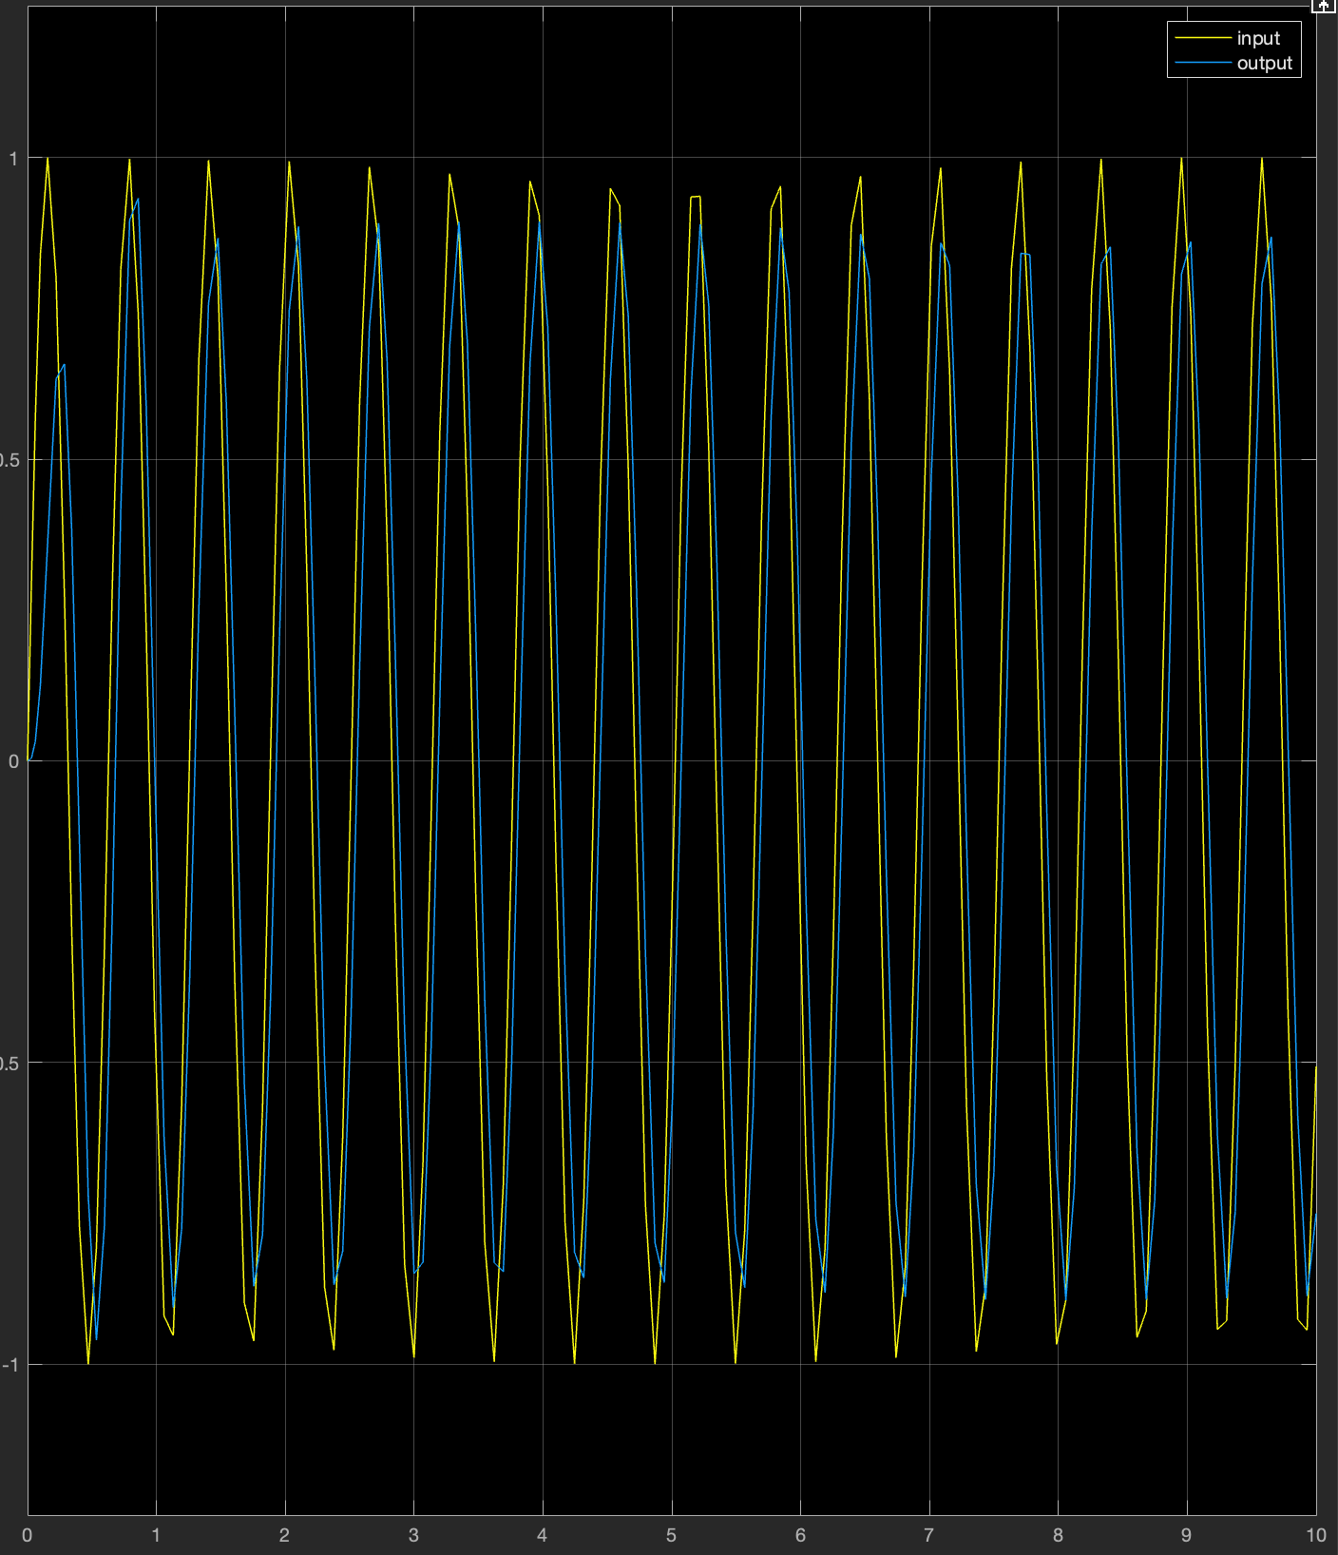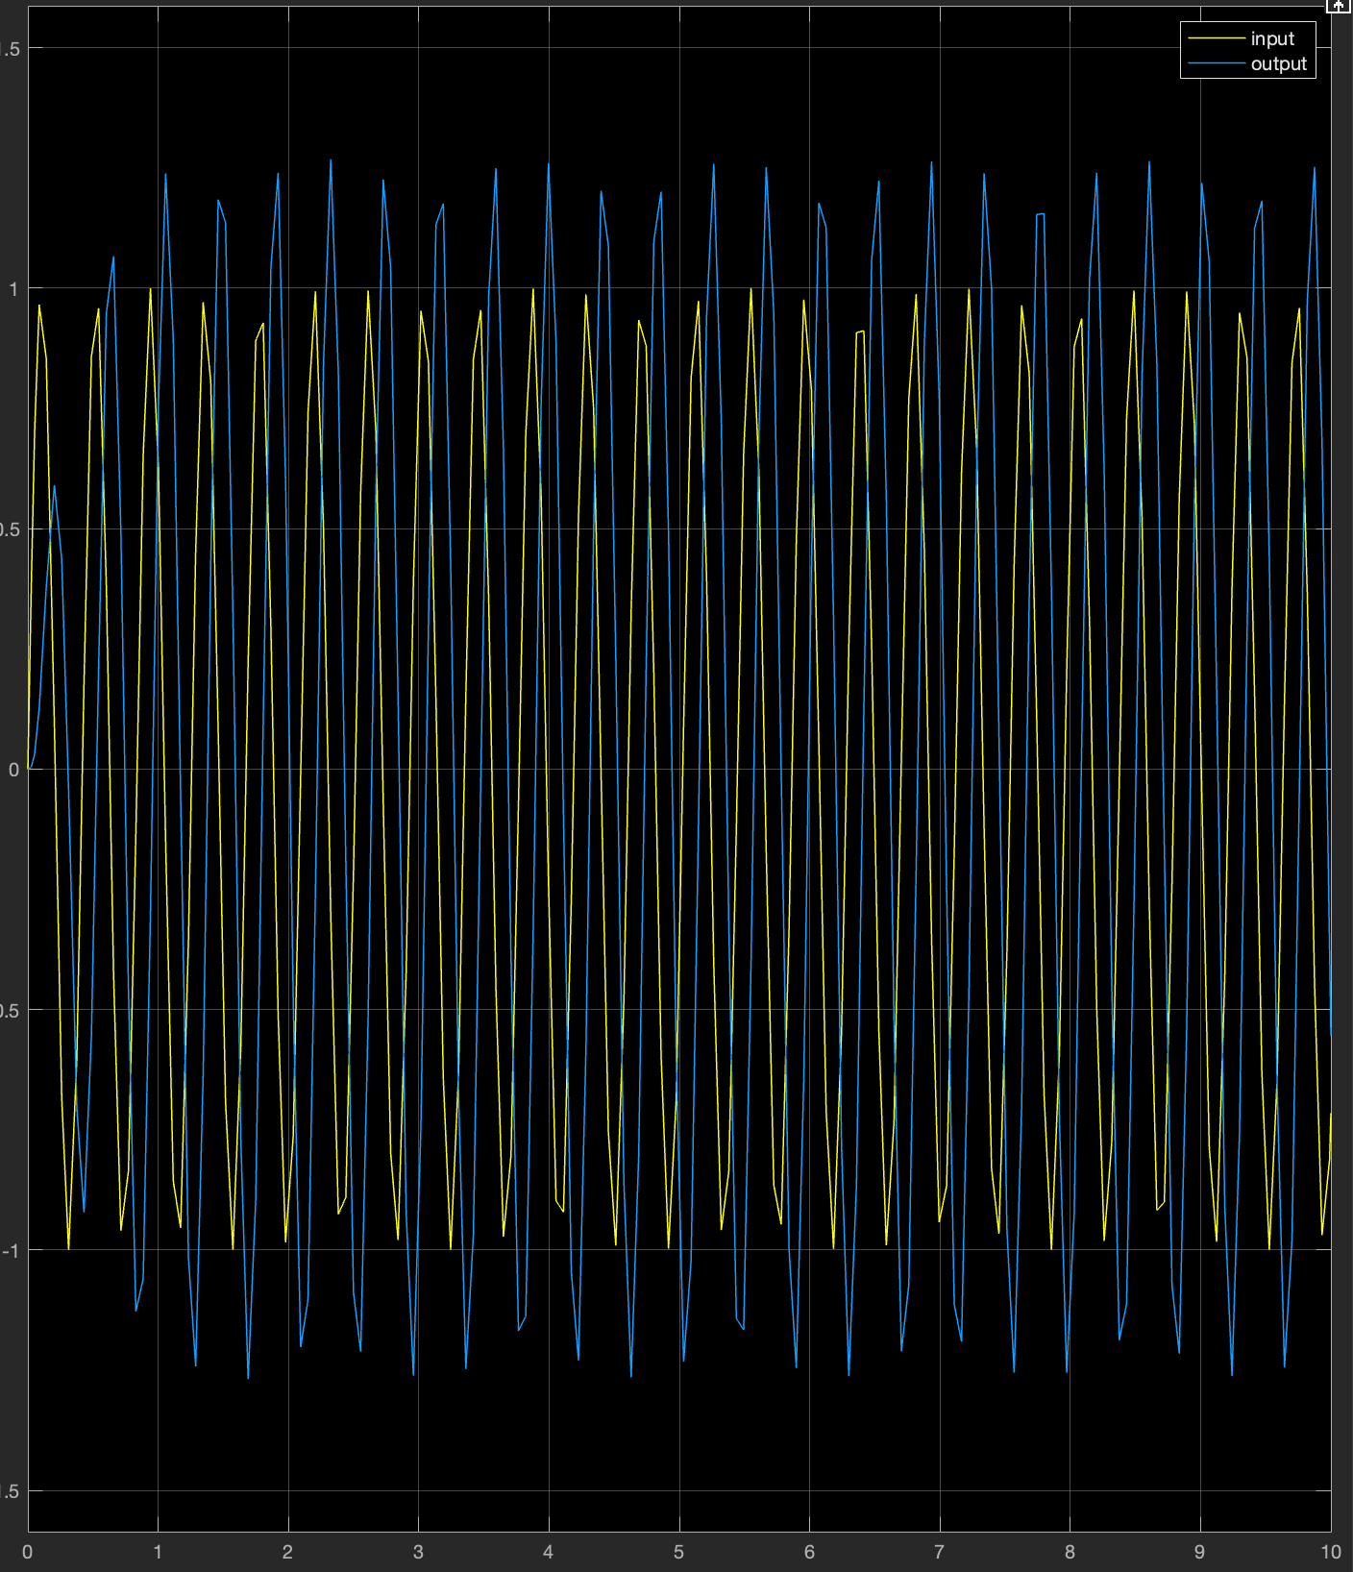
The difference between the peaks is minimised at omega = 10 and this is because this is the natural frequency of the plant

b)
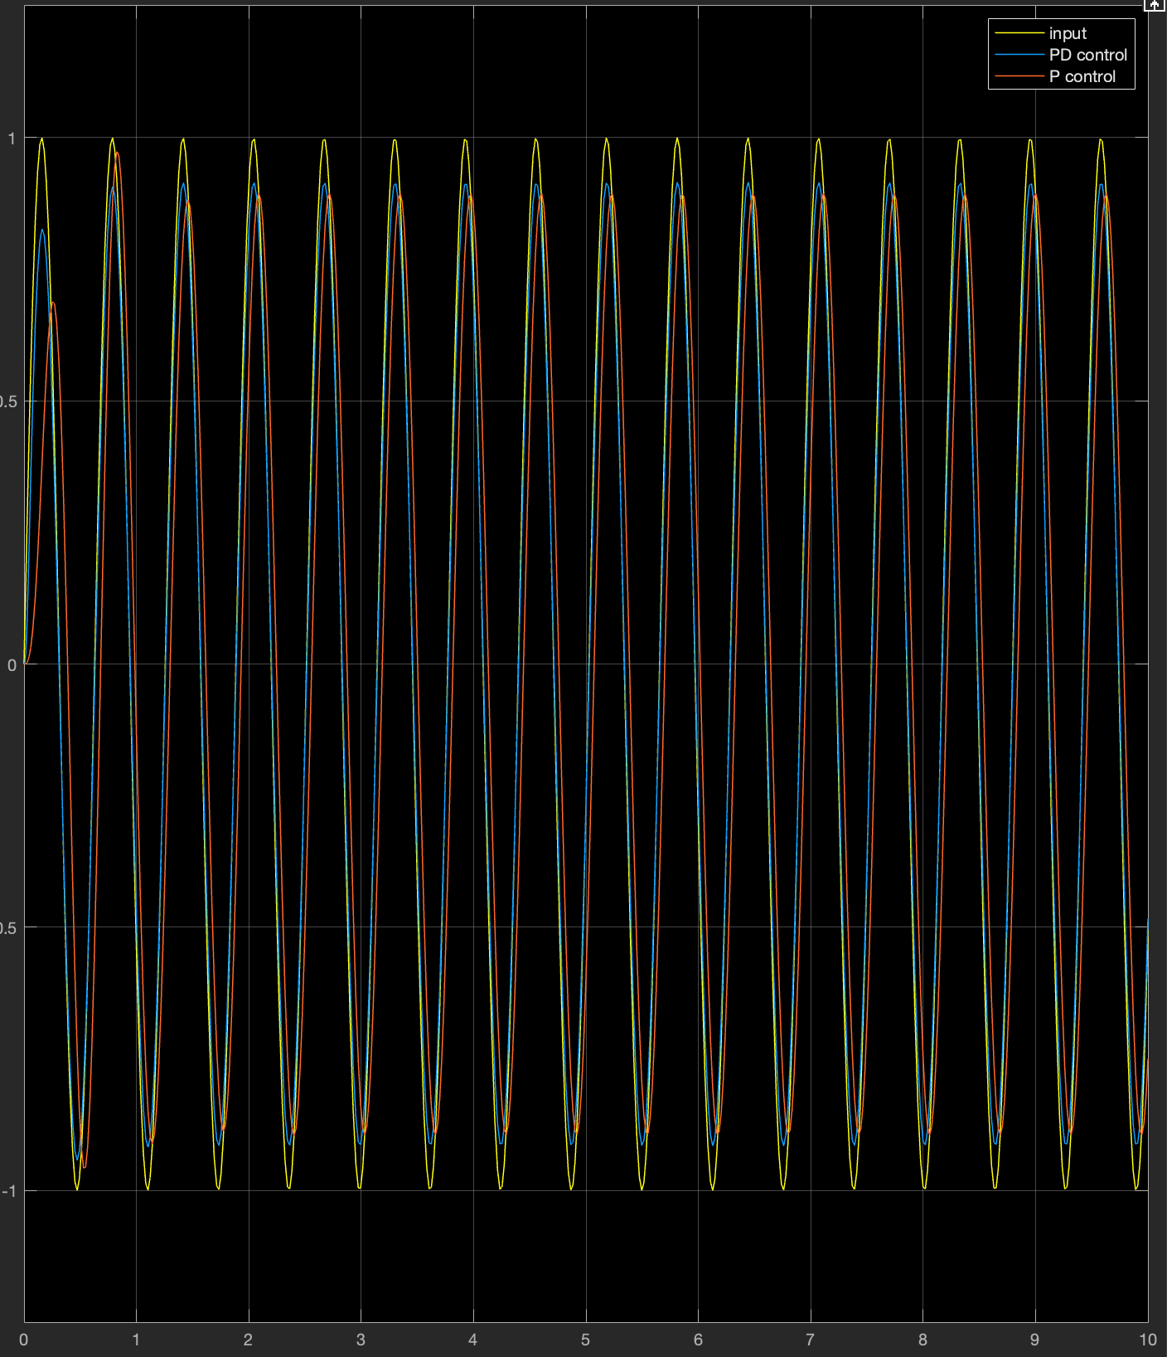

The derivative is in phase with the direction that the output needs to go, meaning that it makes the response move slightly faster, meaning that the output gets closer to the input.

c)
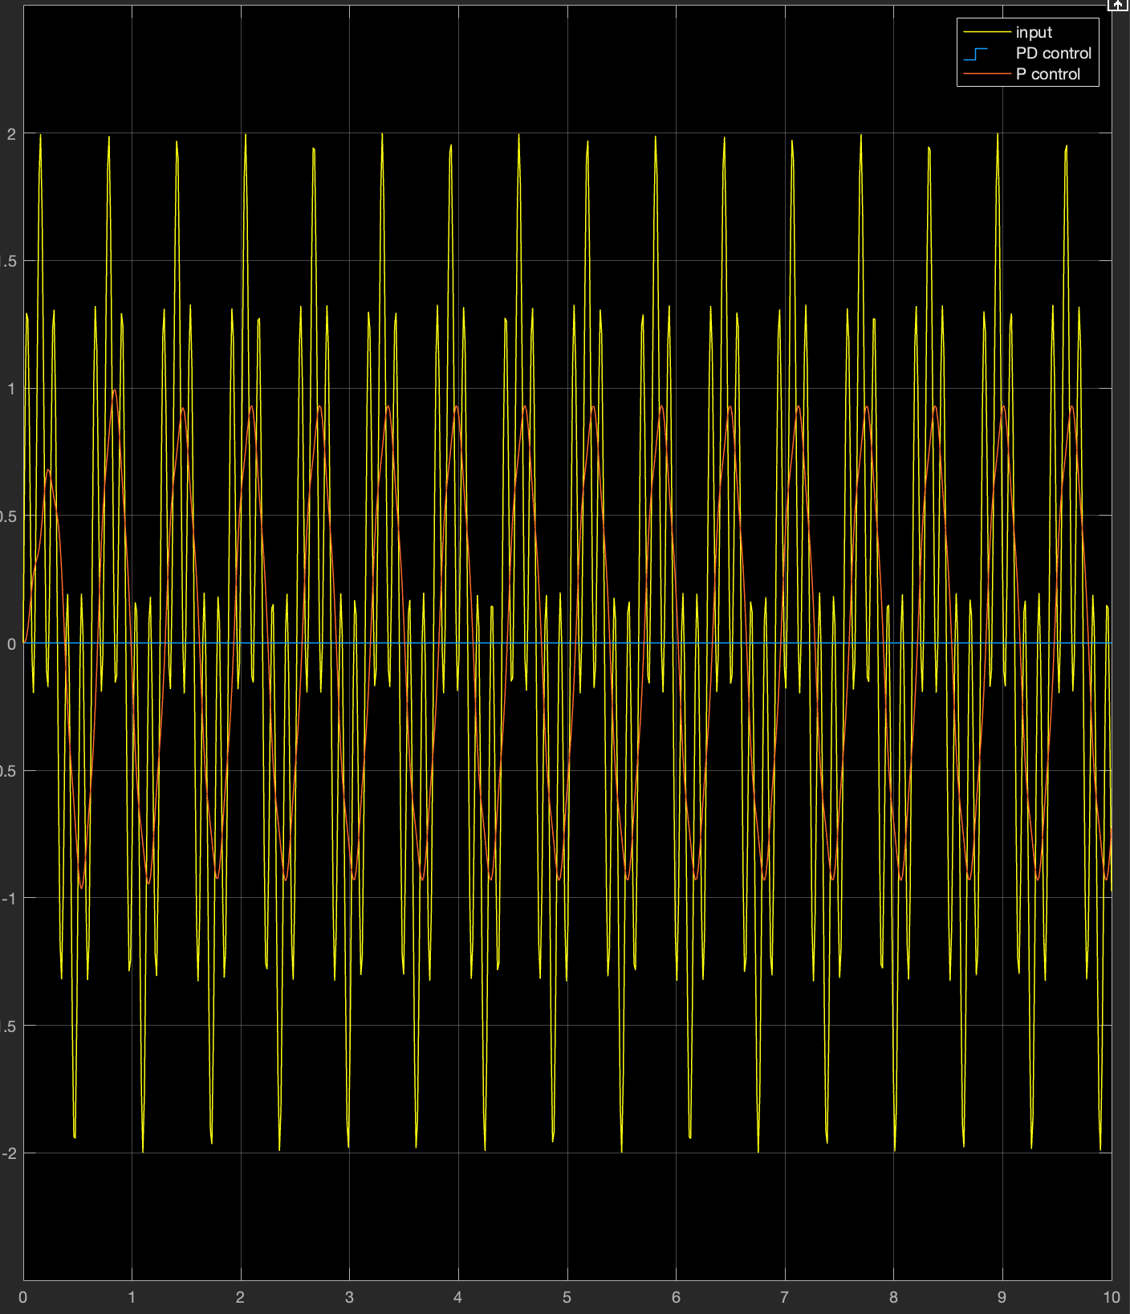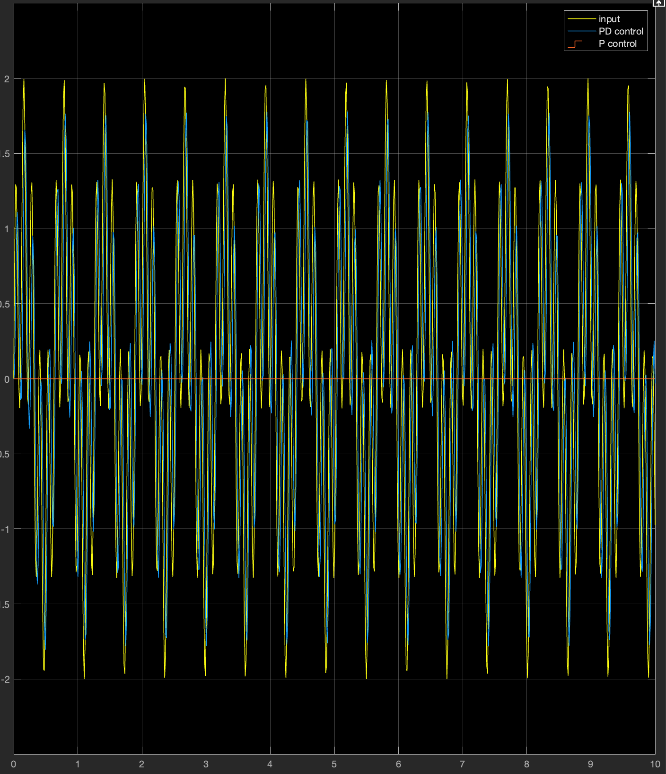
Pure P control better rejects the noise, which is good for most applications. The derivative control amplifies the noise.

d)
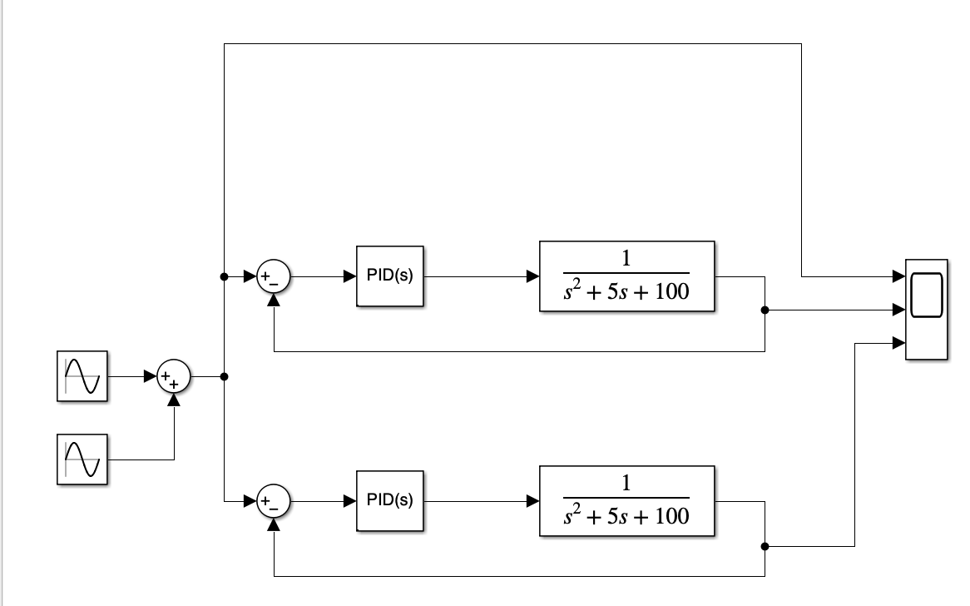

2)
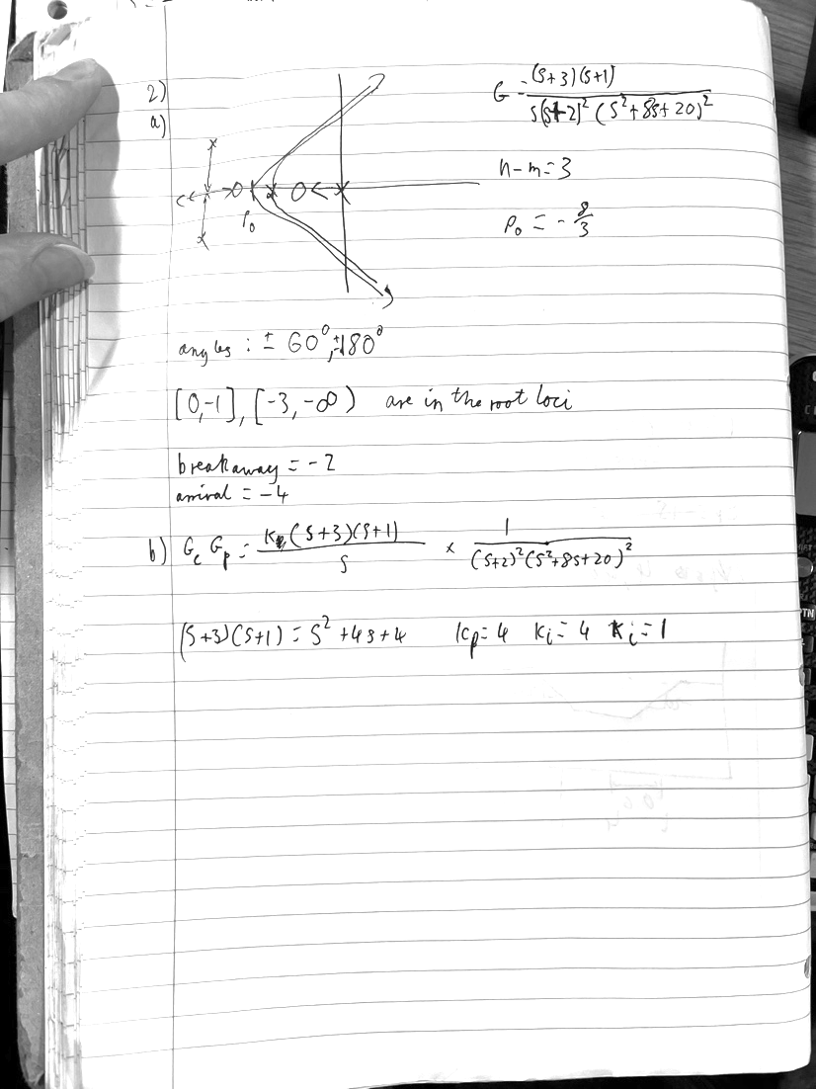

3)
