Fluid dynamics is inherently complicated, as are the equations that govern it. One way to reduce this complexity when running tests is by removing the equations and their intricacies. A simple, low-fidelity way to do this is by using smoke in a wind tunnel, but this can only give relatively low-resolution detail about how the fluid is moving. To answer more complex questions, more advanced methods have been developed. The one that I will be working on is known as Particle Image Velocimetry, and it works by putting small particles in the flow, and then following where these particles go.
To identify a particle at two different points in time, the positions need to be fairly close together. To do this, high-speed cameras and bright laser systems have historically been used. These are obviously very expensive, limiting the use of these systems to institutions with enough funding . Additionally, more volume of fluid needs more cameras, so measuring large volumes can either cost a lot of money, or need trade offs. Work has been done to bring down the cost of these methods to allow more researchers to use it in the past, and my project will be a continuation of this. I will be using a camera that is similar to one in your phone, and some bright LEDs to bring down the cost. The light will be flashed different colours at different times, resulting in an image like the ones below.
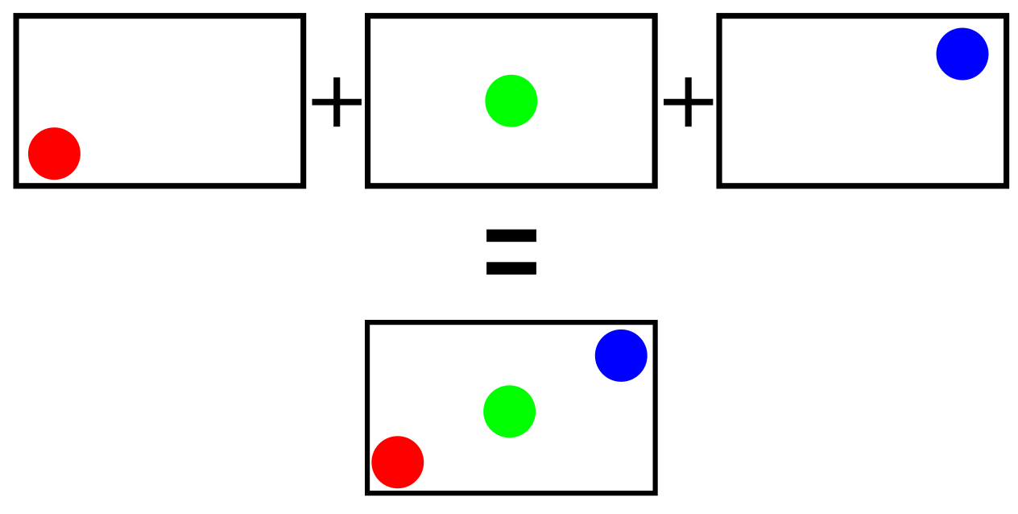
An illustration of what the tracking may look like
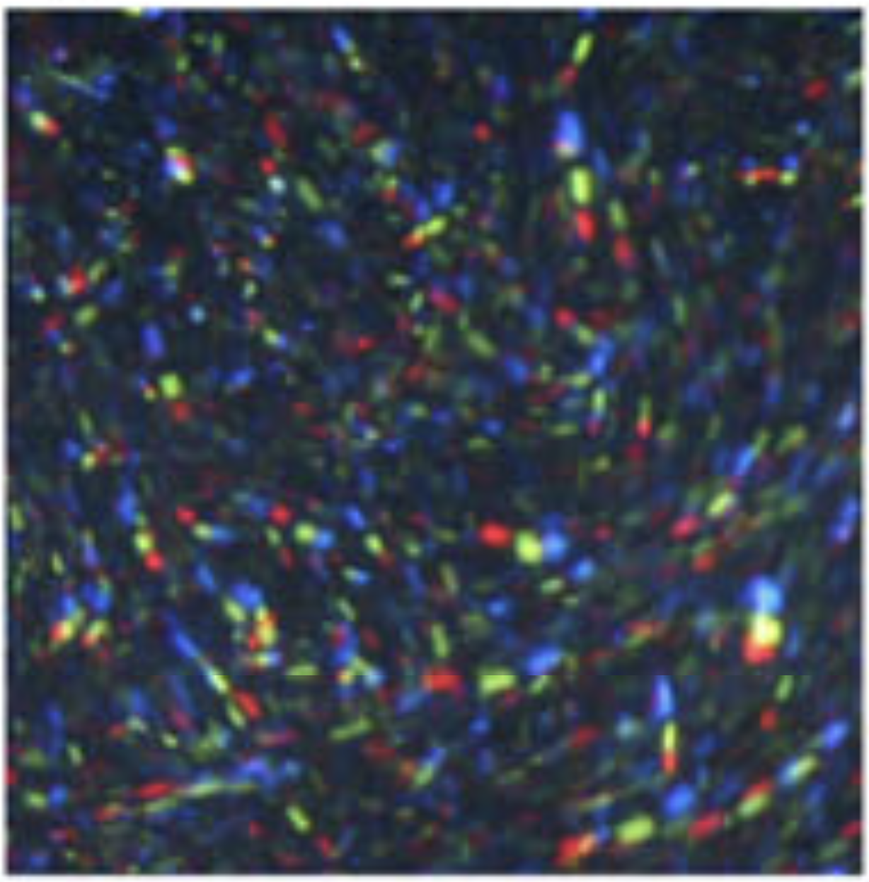

A real image using a similar technique from existing work (Wang & Wang, 2017)

The issue I will be dealing with in my project is that green light from the cameras doesn’t only activate the green pixel, the red and blue pixels also detect some light, and the same is true for all of the other combinations of colours. This could result in the software thinking that there are more particles than really exist, leading to issues tracking the fluid flow. The amount that each light affects each other channel isn’t linear, and the diagram to the left represents this.
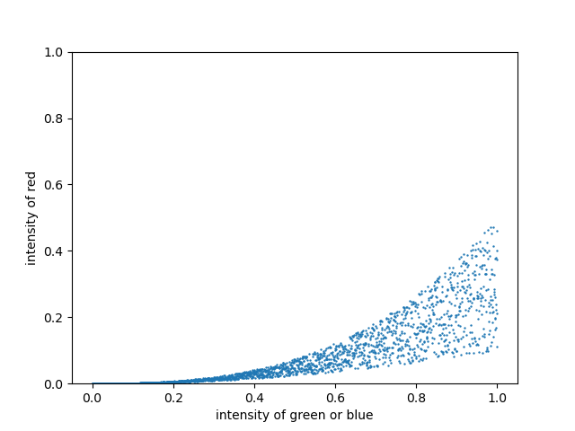

A representation of how the colour channels affect each other. This isn’t real data, but it is indicative of trends
My project will involve getting data from real cameras and LEDs and seeing what the curve looks like. Then, I will simulate this effect in software.
Once the software is working well, I will gather experimental data from in a lab and test my software against that data, it is pointless to have code that works well for made up data but breaks when it deals with the imperfections of the real world.

